## GIT EXERCISE 2

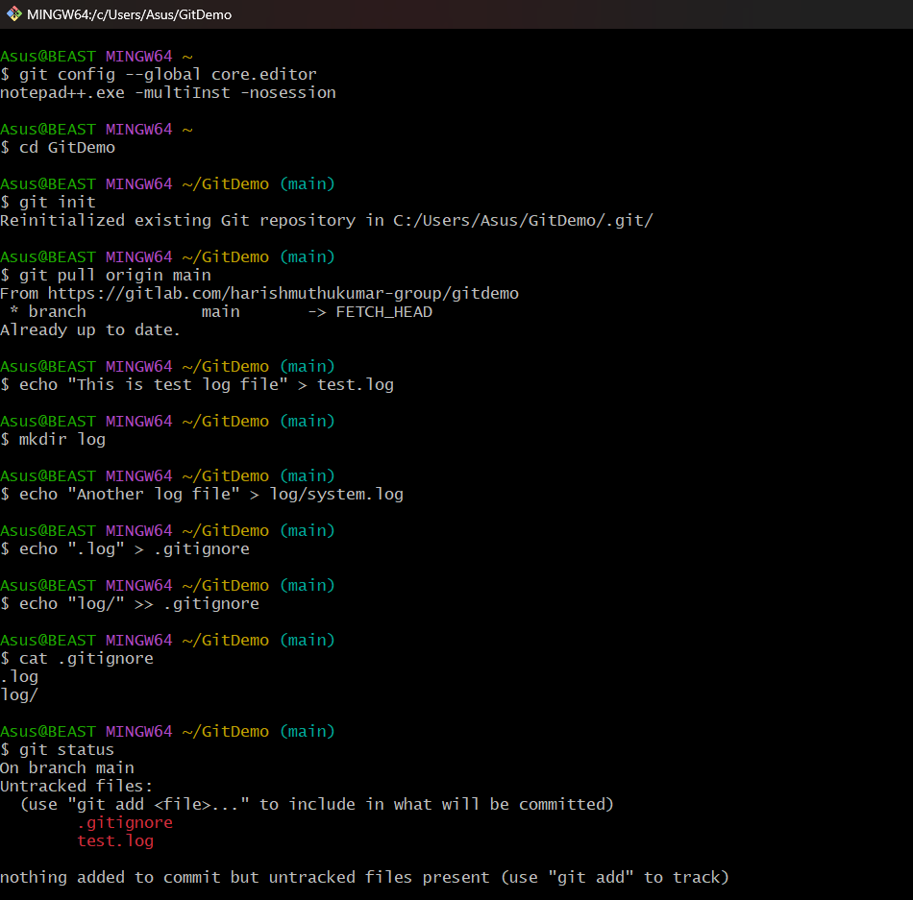

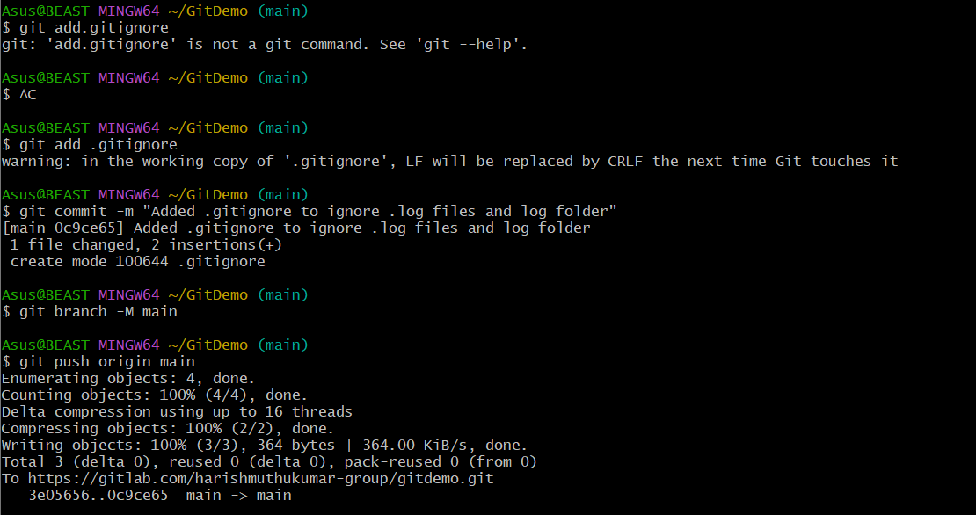

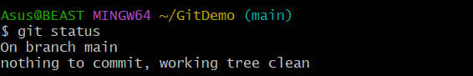

**OUTPUT:**

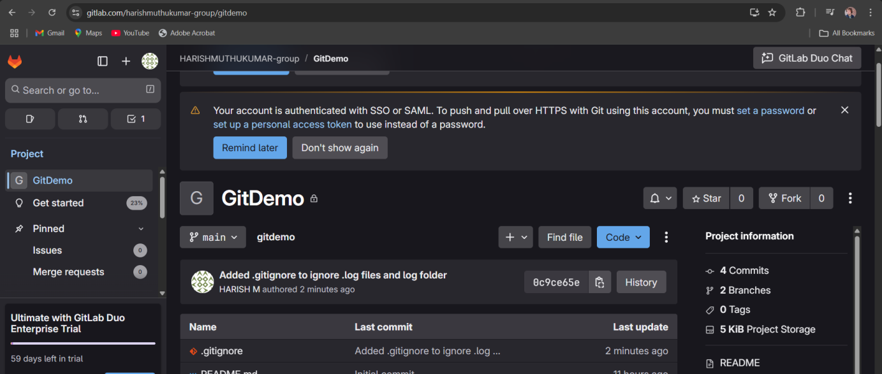

**OBJECTIVES:**

**1. Explain .gitignore**  
The .gitignore file in Git is used to specify which files and folders should be ignored by Git. Any file or directory listed in .gitignore will not be tracked, staged, or committed. This is useful for excluding temporary files, build artifacts, logs, and other files that are not needed in the version control history.

**2. Explain how to ignore unwanted files using .gitignore**  
To ignore unwanted files, create or edit a .gitignore file in the root of the repository and add patterns for the files or folders to be ignored. For example:

*.log

log/

This will ignore all files ending with .log and the entire log folder. After updating .gitignore, save it, add it to Git using git add .gitignore, commit the changes, and push them. Files matching the patterns will no longer appear in git status or be included in commits.